Lab Number 2 Report

Ben Simpson, Section # 001

Benjamin Bergeson, Section # 001

**Introduction**

This lab is intended for us to: (1) get used to the operation of a semiconductor diode, and (2) design and conduct experiments, as well as to analyze and interpret data.

**Background**

 (1)



(2)

We compared two different diode models. One is the exponential model, given by equation (1) above, the other is exponential model that takes into account series resistance, given by equation (2) above. We plotted these using MATLAB (shown in figure 1.) The plot for equation (1) is shown in blue and the plot for equation (2) is shown in red.

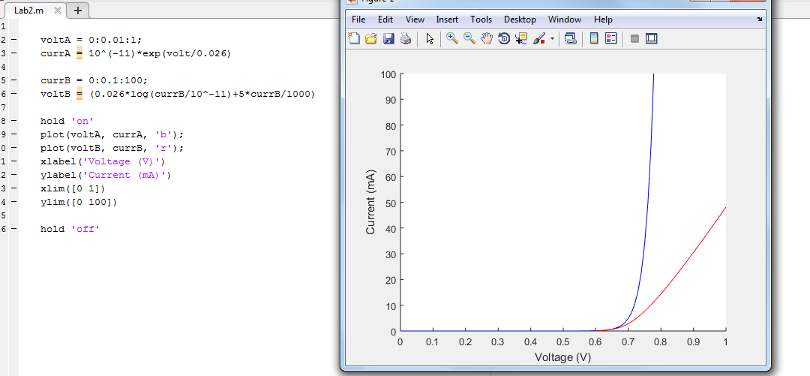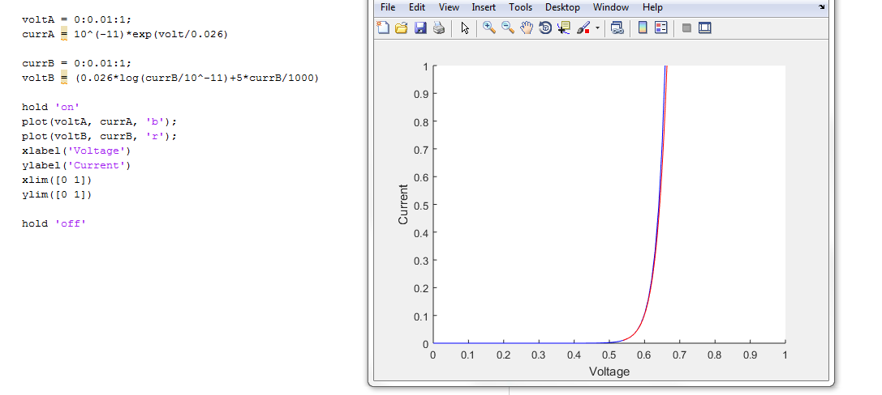

Figure 1 MATLAB Plots

The model represented by equation (1) and equation (2) have similar results in the lower amperage range (0<*I­­d*<1 mA), however, at higher amperage (0<*Id*<100 mA) they have fairly different data. We would want to use equation (1) for low amperages and equation (2) for high amperages.

For the top portion the turn on voltage that we would use is 0.65 V. For the bottom portion we would use 0.78V.

The ideal turn on voltage can be decided based on the current expected. For a higher current you would want higher turn on voltage and vice versa.

**Laboratory Section**

**Part 1:**

Objective: The objective is to create an I/V curve and extract the diode parameters *Is* and *Rd* for the red LED from our lab kit. Figure 2 shows the circuit that we need to build to measure *Is* and *Rd*.

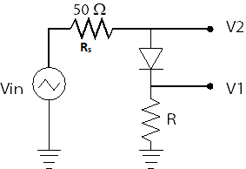

Figure 2 LED Circuit

We made a circuit to measure the internal resistance (*Rd*) and voltage drop (*Vd*) of the diode. We used a 1 kΩ resistor as our R. That did not produce a high enough current through the LED. So we switched R to be a 10 Ω resistor. The final circuit can be seen in figure 3.

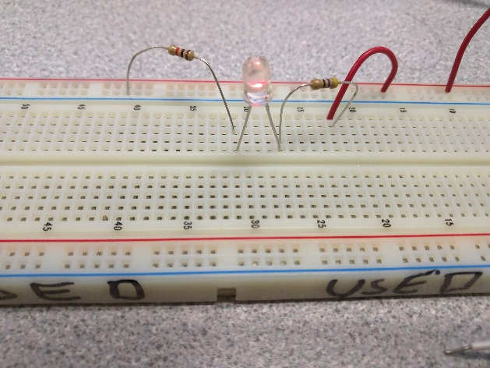

Figure 3 LED Circuit photo

We used a 1 kHz triangle input voltage to measure our V1 and V2. Our waveforms that we obtained on the oscilloscope can be seen in figure 4.

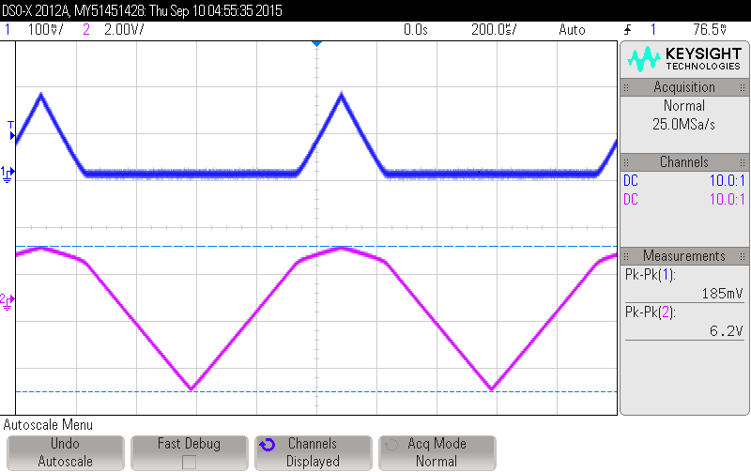

Figure 4 Measured Voltages from LED Circuit

We noticed that as we increased the input voltage, the triangle in V1 increased in magnitude and became more pronounced.

We tried building the circuit with a much lower resistance resistor. We noticed that the triangle waves form the signal generator became rounded. The diode is acting as a capacitor when the voltage is negative. This alters the signal, because there is a built up charge on the diode each cycle.

After importing the .csv from the oscilloscope and plugging it into MATLAB, we graphed the plots for *Vd*and *Id*. The graphs, as well as the source code, can be seen in figure 5.

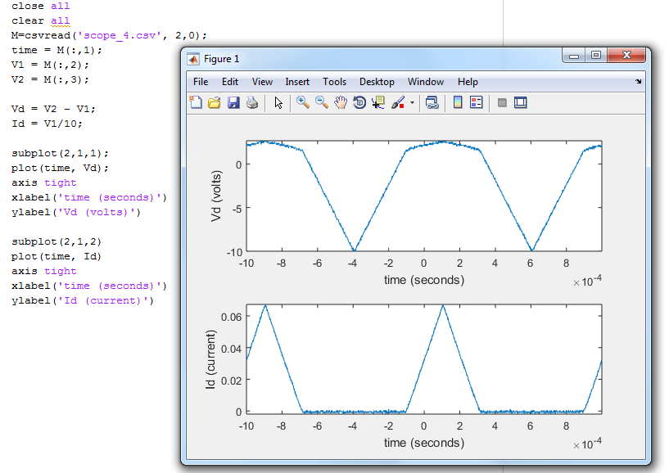

Figure 5 Vd and Id Plot and Source Code

Using the source code given and after some trial and error, we obtained the source code that would plot a line similar to our oscilloscope results. We created a graph based on our model, and compared it to our data. We adjusted the parameters in the graph until the graph of our model fit the data. This is known as parameter extraction. After doing so we obtained the following values: *Is*: 10-28 A, *Rd*: 15 Ω. The turn on voltage is around 2.5 volts. The source code as well as the graph can be seen in figure 6.

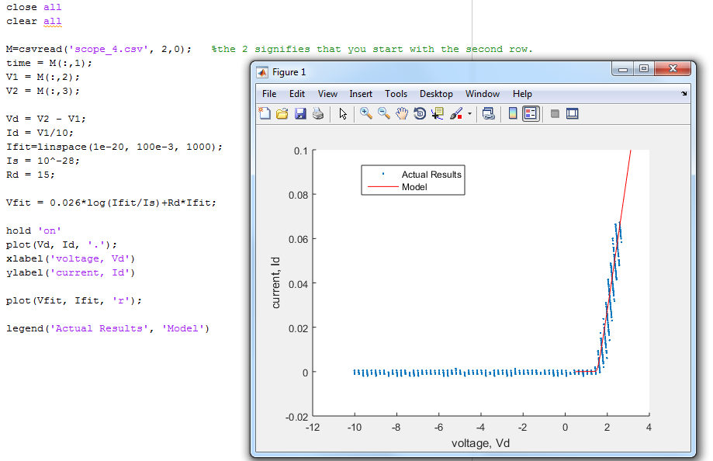

Figure 6 Source Code and Graph for Parameter Extraction

**Part 2 LED:**

Objective: Design and build a simple circuit to turn on the LED with a specific DC current.

Our calculations (shown in figure 7) showed that we should use a 68 Ω resistor in series with the LED. However, that gave us too small of a current. After several trial and errors, we put a 39 Ω resistor in series with the LED and obtained a current of 59 mA.

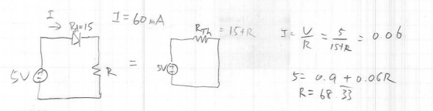

Figure 7 Calculatoins for R

**Part 3 Photodiode:**

Objective: Learn how to use photodiodes to detect light.

We used a 100 Ω in series with the photodiode in reverse bias to obtain a 1 V drop across the resistor when the photodiode is facing the lights. Our calculations (shown in figure 8) show that the voltage generated by the photodiode facing the room lights is 10 mA.

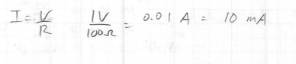

Figure 8 Calculations to Determine Current Generated By Photodiode Facing Room Lights

We used a 12 kΩ resistor in series with the photodiode facing the LED and got a voltage drop across the resistor of 0.974 V. Using this value we were able to calculate the current generated by the photodiode facing the LED to be 81.1µA. The calculations can be seen in figure 9.

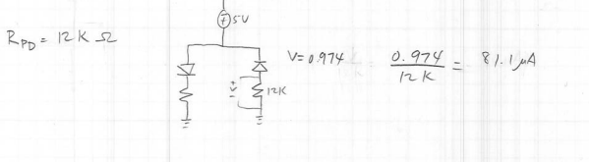

Figure 9 Calculations to Determine Current Generated By Photodiode Facing LED

**Conclusion**

This lab was able to expose us to working with diodes, light emitting and photo. We learned how to perform parameter extraction using data gathered from the oscilloscope and MATLAB. We learned that sometimes it takes several attempts to find the correct component to yield the result that matches our specifications.